✅ Random Order Controller



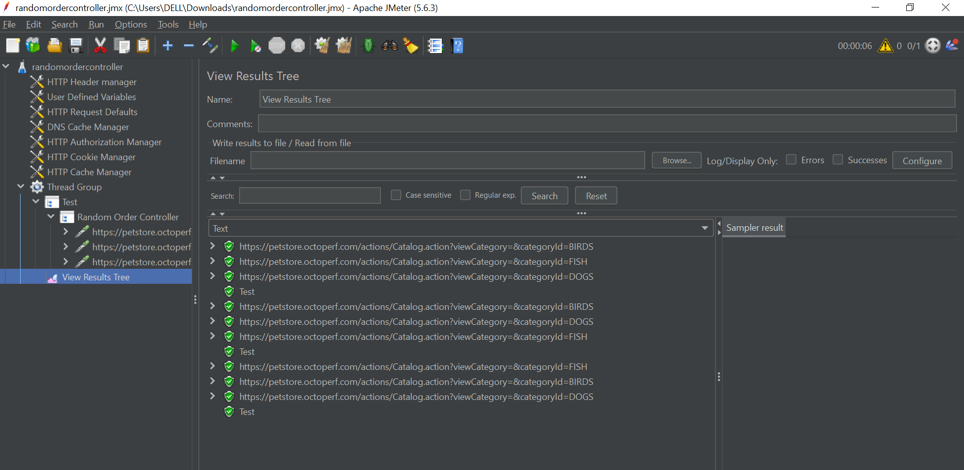

The **Random Order Controller** is a **Logic Controller** in JMeter that executes *all* its child elements once **per iteration**, but **in a randomized order**.

**🧠 How It Works**

* During each iteration of its parent (e.g., Thread Group or Loop Controller), it:
  + Collects its **direct child elements**
  + **Shuffles** them into a new random order
  + Executes them **sequentially** in that new order
* This randomization occurs **in every loop iteration**, so users experience a different sequence of actions each time.

**🔍 Key Characteristics**

| **Feature** | **Random Order Controller** |
| --- | --- |
| Executes all children? | ✅ Yes |
| Randomizes execution order? | ✅ Yes |
| Changes order every iteration? | ✅ Yes |
| Custom configuration? | ❌ None other than Name |

**🎯 When to Use**

Use the Random Order Controller when you want to simulate:

* Realistic user journeys where **order of actions varies** between users or sessions.
* Scenarios to **test caching**, **session state**, or **concurrency issues**.
* **Unpredictable behavior patterns**, such as browsing an e-commerce site.

**💡 Common Use Cases**

1. **E-commerce site navigation**  
   Users might:
   * Visit homepage
   * Search for a product
   * View product details
   * Visit the cart

But not necessarily in that order.

1. **Stress-testing random session paths**  
   Useful to test how your application handles **random navigation patterns** that are more reflective of real-world usage.

**🛠️ How to Add It**

**Steps:**

1. Right-click on a Thread Group > **Add > Logic Controller > Random Order Controller**
2. Add child elements under it (e.g., HTTP Requests, Samplers, Timers)

plaintext

CopyEdit

Thread Group (Loop Count: 3)

└─ Random Order Controller (User Session Actions)

├─ HTTP Request – Homepage

├─ HTTP Request – Search

├─ HTTP Request – Product Details

└─ HTTP Request – Cart

Each iteration will shuffle and execute the 4 requests in a **different order**.

**🔄 Execution Flow Example**

plaintext

CopyEdit

Loop 1: Search → Homepage → Cart → Product Details

Loop 2: Homepage → Product Details → Search → Cart

Loop 3: Cart → Product Details → Homepage → Search

**⚖️ Random Order Controller vs Random Controller**

| **Feature** | **Random Order Controller** | **Random Controller** |
| --- | --- | --- |
| Executes all children? | ✅ Yes | ❌ Only one |
| Order of execution? | 🔀 Random every time | 🎯 Random single pick |
| Simulates? | Complete unpredictable user journeys | One-off random events |

**✅ Summary**

Use **Random Order Controller** when:

* The same actions must be executed every time
* Their **execution sequence should vary**
* You want to better simulate **non-linear user behavior**

Don’t confuse it with the **Random Controller**, which selects just **one child randomly** per iteration.